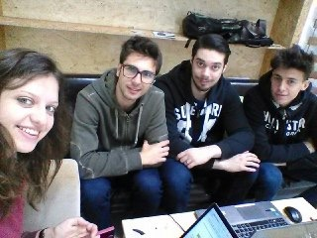Team1 “Smart Mirror” project

Member:

* Boris di Chio
* Andrea Russotto
* Alexandra Maria Farcas
* Jari Giuseppe Stimoli

**The idea**

We had the idea to create a mirror, a smart mirror, to allow the users to save time in the morning and become aware of the information they want to know.

This is because consult information such as traffic, news, emails is always a waste of time if you are in a hurry.

We started with the idea to take a true mirror that showed the information trough a display device placed behind the mirror (the screen of a smartphone or a tablet).

Cause some problems related to the material and tools we preferred to use a pc monitor connected with a webcam.

**At the beginning**

The first idea was to build a “Smart mirror” based on a real mirror and a display (in trasparency) that showes in a portion of the mirror some information like: unread emails or traffic conditions or weather and other contents, chosen by the user with his smartphone.

**The actual project**

The actual project consist of in a LCD monitor, connected with a laptop and a webcam.

With Processing we developed the program to run so that the lcd and the webcam will be our mirror.

In a portion of this LCD screen there is a matt bar where you can view the weather, reminders and unread emails while you prepare in the morning before leaving home.

**How we worked**

We started from a "Processing Example" to use our webcam and we use code withdrawn from GitHub.

We flipped and rotate the image on the screen to create a "mirror effect".

After that we drawed the rect bar on side and we started to add a "lorem ipsum" to create a prototype.

At a later time we added the real information.

For first we added the weather using yahoo weather libraries.

After the weather we used google API's to take the information (unread emails and events) directly pushing the user data.

In processing we exploit Temboo libraries to connect the API's with our program and retrieve all the requested information.

**Special features**

Our mirror turns on and show the information only when a human place in front of him.

**Wood**

The monitor is not only a monitor. We recreate a real wood frame, decorated and with a pedestal.

All is stucked with screws and a wood plate.

Now the display looks like a real elegant classic mirror.